

EXPERIMENT REPORT

|  |  |
| --- | --- |
| **Experiment Name** | Nonlinear Applications of Operational Amplifiers |
| **Lab Assistant** | Mesut Atasoyu |
| **Author of the Report (Name / No / Department)** | Tuğrul YATAĞAN  040100117  Computer Engineering |
| **Group Number and**  **Experiment Date** | D27  29.11.2013 |

|  |  |  |
| --- | --- | --- |
| **Report Score** | **Deliver Date** | **Receive Date** |
|  | 06.12.2013 |  |

### Aim of the Experiment

In this experiment session, we investigate basic understanding of operational amplifiers (op-amps) for performing nonlinear applications such as voltage comparator, schmitt trigger and rectifier circuits.

### Exp #1 Voltage Comparator

We provide 20V peak to peak triangle wave signal to input V1. With the help of potentiometer, we can set various values for Vref voltages and measure the peak to peak voltage of output signal from oscilloscope.

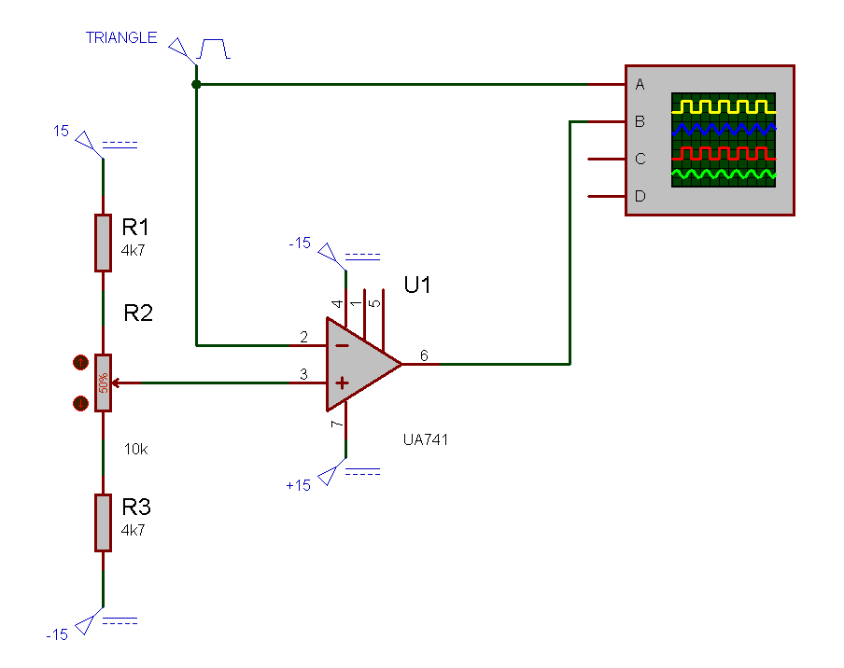

We set the circuit above and observed the result like the following. Duty cycle of output signal was effected by potentiometer.

### 

### Exp #2 Voltage Limited Comparator

We provide 20V peak to peak triangle wave signal to input V1. At the end of the opamp’s output we set two 5.1V zener diodes for limiting output signal. With the help of potentiometer, we can set various values for Vref voltages and measure the peak to peak voltage of output signal from oscilloscope.

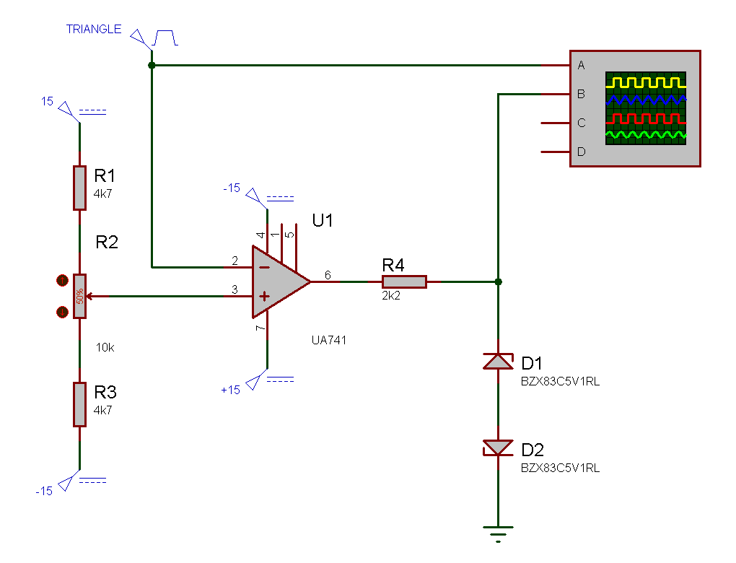

We set the circuit above and observed the result like the following. Duty cycle of output signal was effected by potentiometer. Peak to peak value of output was limited by zener diode which is approximately sum of Vforward + Vbackward = 0.7V + 5.1V = 5.8V forwadr and backward voltages of zener.

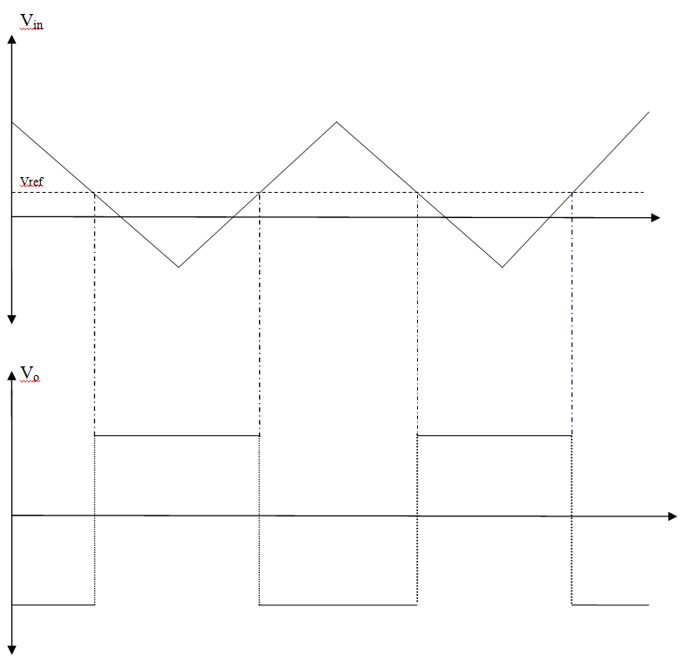

### Exp #3 Schmitt Trigger

We provide 20V peak to peak voltage to opamp. With the help of potentiometer, we can set various values for Vref voltages and measure the peak to peak voltage of output signal from oscilloscope and we observed the hysteresis.

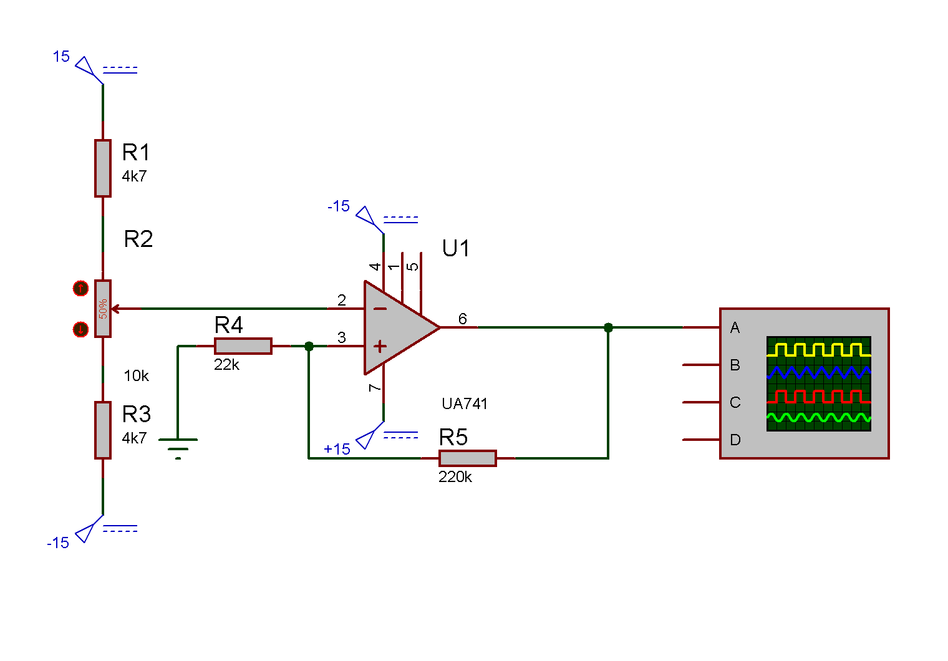

We set the circuit above and observed the result like the following. DC output level of signal was affected by potentiometer at certain points.

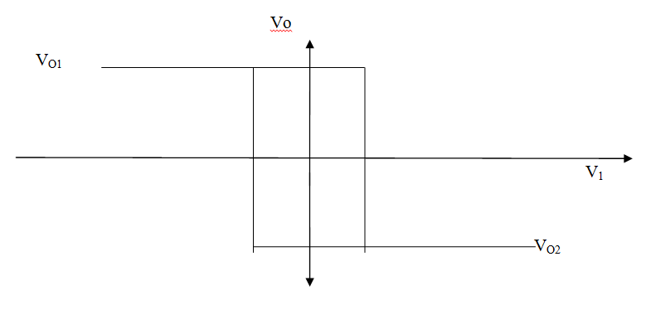

$$V_{omax}= +10V$$

$V_{omin}= -$ 10V

$$V_{11}= \frac{R_{1}}{R_{1}+ R_{P}}V_{omax}$$

$$V_{12}= \frac{R_{1}}{R_{1}+ R_{P}}V_{omin}$$

$$V_{11}= \frac{220k}{220k+22k}10V=9.09V$$

$$V_{12}= \frac{220k}{220k+22k}\left(-10V\right)=-9.09V$$

### Exp #4 Full wave rectifier

We provide 20V peak to peak sinusoidal wave signal to input V1. At the end of the first opamp’s output we set two 5.1V zener diodes for limiting output signal of first opamp. First opamp’s output is connected the second opamp’s input. With the help of potentiometer, we can set various values for feedback Vref voltages and measure the peak to peak voltage of output signal from oscilloscope.

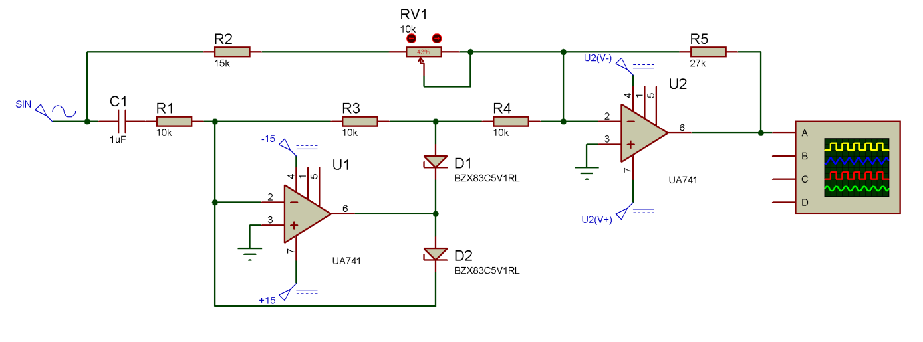

We set the circuit above and observed the result like the following. Reference value was affected by potentiometer this results clipping on output sinusoidal signal.